Semester 1 Examination, 2003

Solutions

CHEMISTRY

PART 1

1. b | 6. c | 11. d | 16. a
2. c | 7. d | 12. c | 17. a
3. a | 8. d | 13. b | 18. d
4. d | 9. b | 14. c | 19. d
5. d | 10. a | 15. a | 20. b

PART 2

(a)
Equation 2Cr(s) + 2OH⁻(aq)+ 6H₂O() → 2[Cr (OH)₄]⁻ (aq) + 3H₂(g)

Observation Metal dissolves - colourless gas is evolved – solution turns green

(b)
Equation Cu⁺²(g) + Mg(s) → Mg⁺²(aq) + Cu(s)

Observation A black deposit forms on the magnesium strip. The solution becomes less blue

(c)
Equation Pb⁺²(aq) + 2I⁻(aq) → PbI ₂(s)

Observation As the colourless solutions are mixed an intense yellow precipitate is formed
2. (a) Ammonia or NH₃

(b) Fluorine or F₂

(c) Any noble gas. Eg He, Ne, Ar, Kr, Xe, Rn

(d) Sodium or Na, Potassium or K

3. (a) Heat it up, this increases the velocity of moving particles giving more collisions with greater chances of success. Also more particles have energy greater than activation energy requirements.
(b) Increase the pressure (concentration) of O₂ and or the droplets of petrol permitting more effective collisions
(c) Convert petrol into spray - droplets have greater surface area which leads to greater possibly of effective collisions
(d) Find a catalyst which permits a lower energy path to products.

4. (a) TEST: Add a soluble barium salt solution to each.

OBSERVATION: H₂SO₄ - white precipitate
HNO₃ – No visible reaction

(b) TEST: Add each to NaOH solution.
OBSERVATION: Aℓ (OH)₃ will dissolve
Mg(OH)₂ will not

(c) TEST: Add a soluble silver salt solution to each.
OBSERVATION: KCℓ → white precipitate
KCH₃C00 → nothing

5.
Solutions | Strong  Electrolyte | Weak  Electrolyte | Non  Electrolyte | Strong  Conductor | Weak  Conductor | Non  Conductor
Calcium  Hydroxide | ✓ |  |  |  | ✓
Nitric Acid | ✓ |  |  | ✓
Sugar |  |  | ✓ |  |  | ✓
Ammonia |  | ✓ |  |  | ✓

6.

Species | Electron dot diagram | Name of shape | Polar or Not?
H  X  S  S  H  H  •  -1  hydrogen sulfite ion  HSO₃⁻ |   x | Pyramid | Polar
beryllium difluoride  BeF₂ | 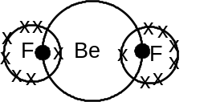 | Linear | Non Polar
tellurium dihydride  TeH₂ | 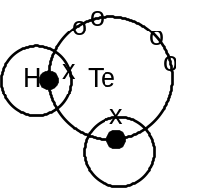 | Bent | Polar
[6 marks]

PART 3

1. (a) m(c) = 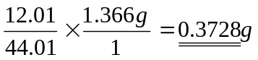
n(OH⁻) = n (H⁺) = n(C⁻) = 30.93 × 10⁻³ × 2.007mol
∴ mass C in sample = n × m
= 30.93 × 10⁻³ × 2.007 × 35.45
= 2.2006g
mass F = mass sample - (mass C + mass C)
= 3.164 - 2.5734
= 0.5906g

 | C | C | F
mass | 0.3728 | 2.2006 | 0.5906
moL's | 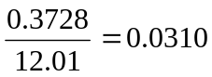 | 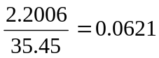 | 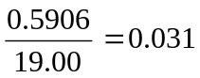
simplest ratio | 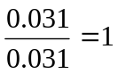 | 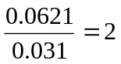
∴ E.F = CC₂F

(b) Molar mass = 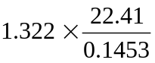
= 203 g moL⁻¹
E F molar mass (CC₂F) = 12.01+ 70.90 + 19.00 = 101.91 g moL⁻¹

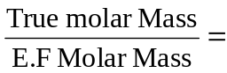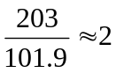

∴ True formular = 2 × E.F. = C₂Cl₄F₂
2. (a) Ba⁺²(aq) + SO₄⁻²(aq) = BaSO₄(s)
n(Ba⁺²)_{in 500 mL} = 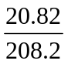 [M(BaC₂) = 208.20 g mol⁻¹]
∴ n(Ba⁺²)_{in 150 mL} = 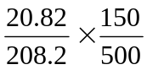 = 0.03 moL

n (SO₄⁻²) in 300 mL 0.1M Na₂SO₄ = 0.03 moL
∴ n (Ba⁺²) = n (SO₄⁻²) = n (BaSO₄) [M(BaSO₄) = 233.36 g mol⁻¹]
∴ m(BaSO₄) = n × m
= 0.03 × 233.36
= 7.00 g

(b) All Ba⁺² and SO₄⁻² is precipitated
∴ 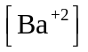 = 0 moL L⁻¹
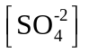 = 0 moL L⁻¹
n(Cℓ⁻) = 2 × n( Ba⁺²)
= 0.06 moL
∴ 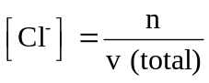
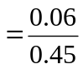 = 0.133 moL L⁻¹
n (Na⁺) = 2 × n (Na₂SO₄) = 0.06
∴ 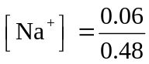 = 0.133 moL L⁻¹
3. Cu CO₃ + H₂SO₄ → CuSO₄ + H₂O + CO₂ Equ 1
H₂SO₄ + 2NaOH → Na₂SO₄ + 2H₂O Equ 2
n (NaOH) to neutralize Excess H₂SO₄ = c × V = 17.6 × 10⁻³ × 0.25 = 0.0044 moL
From Equ 2 n(H₂SO₄) = ½ n(NaOH) = 0.0022 mol
n(H₂SO₄) _{original} = c × V = 25 × 10⁻³ × 0.250 = 0.00625 moL
∴ n(H₂SO₄) _{used} = 0.00625 - 0.00220 = 00405 mol
From Equ 1 n(H₂SO₄) _{used} = n(CuCO₃) = n(Cu⁺²)
∴ m(Cu) _{in sample} = n × m = 0.00405 × 63.55 = 0.2574 g
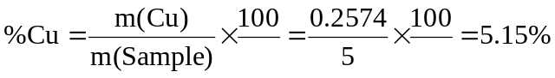

4. (a) (NH₄)₂CO₃ → 2NH₃ + CO₂ + H₂O
n (NH₄)₂CO₃ = 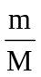 = 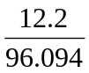 = 0.1270 moL
From Equation total number of moles produced = 4 × n((NH₄)₂CO₃)
= 4 x 0.1270 = 0.508 moL
(b) PV = nRT ∴ P = 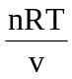
= 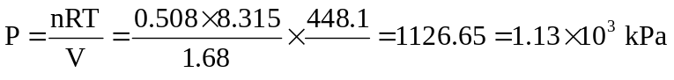

(c) n(CO₂) = n(NH₄)₂CO₃ = 0.1270 moL
∴ m(CO₂) = n × M = 0.1270 × 44.01 = 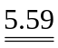g

For answers to the Part 4 please see the section containing Extended Answer Questions

